**NEC Corporation India**

**Table of Contents**

1. Appendix
2. Configuration Requirements
3. Setting up virtual environment
4. Deployment

**Deployment and Configuration**

1. **Appendix**
2. 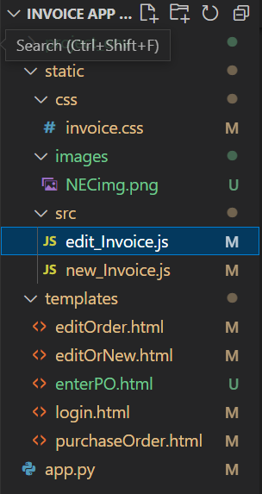 **Configuration Requirements**
3. Python v3.6 or greater
4. Flask(Flask installation using command prompt - **pip install flask)**
5. mySQL Server(version 8.0.29.0)
6. Internet Connection(some of the fonts and js get imported online)
7. **Setting up Virtual Environment**
8. Open PowerShell and write the following command

* pip install virtualenv
* python -m venv project_env
* pip install mysql-connector-python
* pip install mysql.connector
* pip install flask_mysqldb
* pip install flask
* pip install mysql

1. Now to switch into this virtual environment, write the following commands in PowerShell.

* Set-ExecutionPolicy Unrestricted -Scope Process
* project_env\Scripts\activate

1. **Deployment**

Flask is a lightweight Python web framework that provides useful tools and features for creating web applications in the Python Language. Flask is also extensible and doesn’t force a particular directory structure or require complicated boilerplate code before getting started.

* Create a new folder and put the entire project within this folder.

Now as you can see in the app.py file, the database name, table name etc are local to every system.

Therefore as for database operations you can create a new table in your database with the specified columns as provided below and edit the table name, database and password in the conn object in app.py file in **executeQuery()**, **insertOrder().**



After all the operations regarding database are done, follow the following steps -

* Then open the command prompt within the project directory and run **python app.py**
* Project will be locally deployed onto your system.
* Go to a web browser and search **- http://127.0.0.1:5000/login**